Types of Network :

Pan (Personal Area Networks):

* Personal Area Network is a network arranged within an individual person, typically within a range of 10 meters.
* Personal Area Network is used for connecting the computer devices of personal use is known as Personal Area Network.
* **Thomas Zimmerman** was the first research scientist to bring the idea of the Personal Area Network.
* Personal Area Network covers an area of **30 feet**.
* Personal computer devices that are used to develop the personal area network are the laptop, mobile phones, media player and play stations.

**There are two types of Personal Area Network:**

**Wireless Personal Area Network:** Wireless Personal Area Network is developed by simply using wireless technologies such as WiFi, Bluetooth. It is a low range network.

**Wired Personal Area Network:** Wired Personal Area Network is created by using the USB.

Examples of PAN are USB, computer, phone, tablet, printer, PDA, etc.

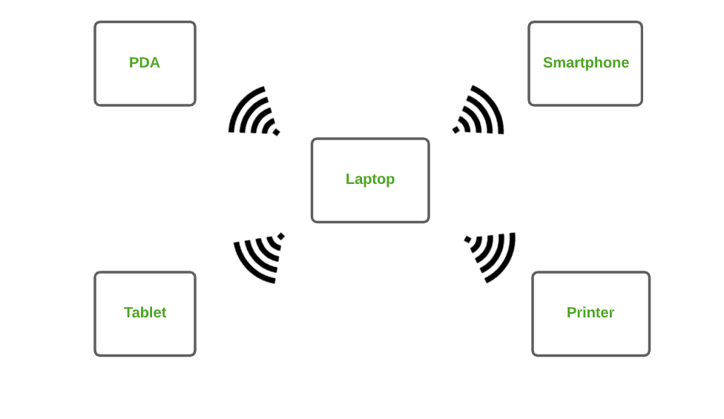

### **2. Local Area Network (LAN)**

* Local Area Network is a group of computers connected to each other in a small area such as building, office.
* LAN is used for connecting two or more personal computers through a communication medium such as twisted pair, coaxial cable, etc.
* It is less costly as it is built with inexpensive hardware such as hubs, network adapters, and ethernet cables.
* The data is transferred at an extremely faster rate in Local Area Network.
* Local Area Network provides higher security.
* The two important technologies involved in this network are [Ethernet](https://www.geeksforgeeks.org/local-area-network-lan-technologies/)and [Wi-fi](https://www.geeksforgeeks.org/what-is-wi-fiwireless-fidelity/).  It ranges up to 2km & transmission speed is very high with easy maintenance and low cost.
* Examples of LAN are networking in a home, school, library, laboratory, college, office, etc.

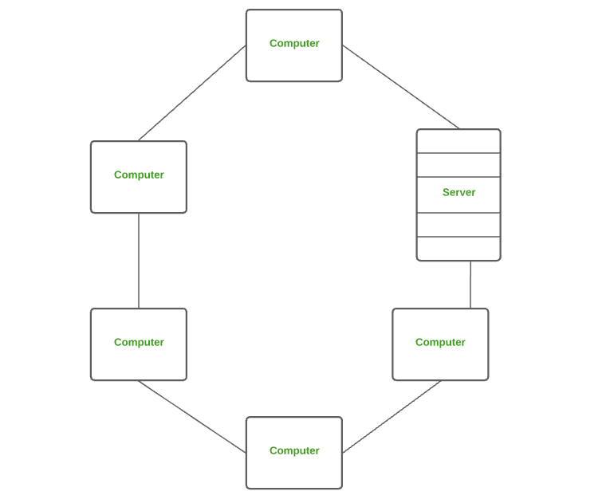

### **3. Campus Area Network (CAN)**

CAN is bigger than a LAN but smaller than a MAN. This is a type of computer network that is usually used in places like a school or colleges.

This network covers a limited geographical area that is, it spreads across several buildings within the campus. [CAN](https://www.geeksforgeeks.org/overview-of-campus-area-network-can/) mainly use Ethernet technology with a range from 1km to 5km.

Its transmission speed is very high with a moderate maintenance cost and moderate cost.

Examples of CAN are networks that cover schools, colleges, buildings, etc.

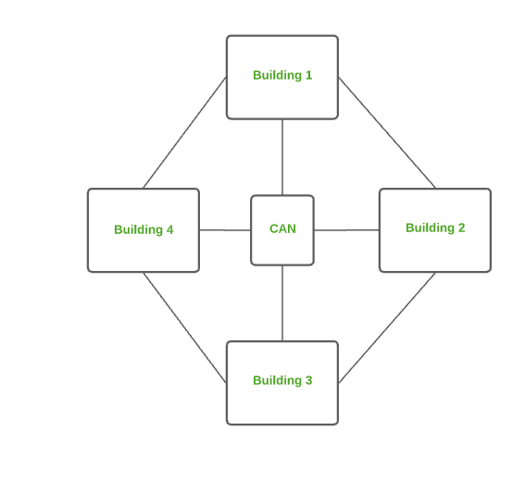

### **4. Metropolitan Area Network (MAN)**

A [MAN](https://www.geeksforgeeks.org/man-full-form-in-computer-networking/) is larger than a LAN but smaller than a WAN. This is the type of computer network that connects computers over a geographical distance through a shared communication path over a city, town, or metropolitan area. This network mainly uses FDDI, CDDI, and ATM as the technology with a range from 5km to 50km. Its transmission speed is average. It is difficult to maintain and it comes with a high cost.

Examples of MAN are networking in towns, cities, a single large city, a large area within multiple buildings, etc.

### **5. Wide Area Network (WAN)**

* A Wide Area Network is a network that extends over a large geographical area such as states or countries.
* A Wide Area Network is quite bigger network than the LAN.
* A Wide Area Network is not limited to a single location, but it spans over a large geographical area through a telephone line, fibre optic cable or satellite links.
* The internet is one of the biggest WAN in the world.
* A Wide Area Network is widely used in the field of Business, government, and education.

